Work-case 2
Made by БІКС-13 students: Ihor Kohut, Artem Bereza, Sofiia Lapchyk
Made by Sofiia Lapchyk:
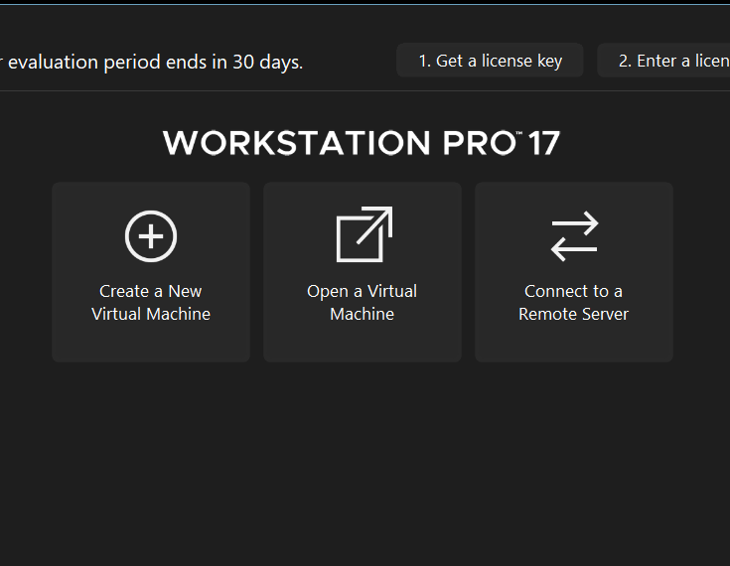
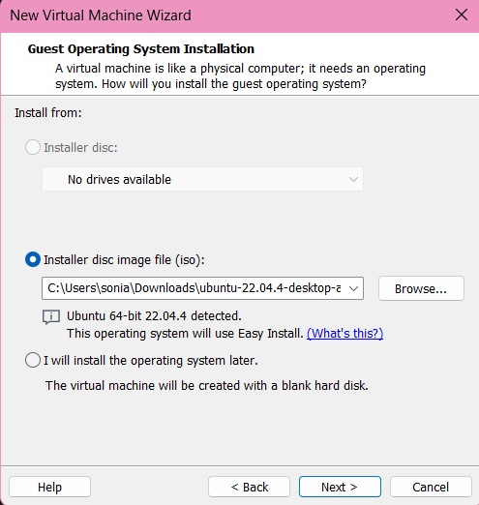
2. Describe a set of basic actions in the hypervisor you installed:
- Creating a new virtual machine:
As soon as you have downloaded hypervisor you should to download ISO image. Open hypervisor and fill in some appropriate details: ISO image, machine folder, name, user profile. Define the virtual machine’s resources: how much of our host machine’s memory and processors the virtual machine can use.
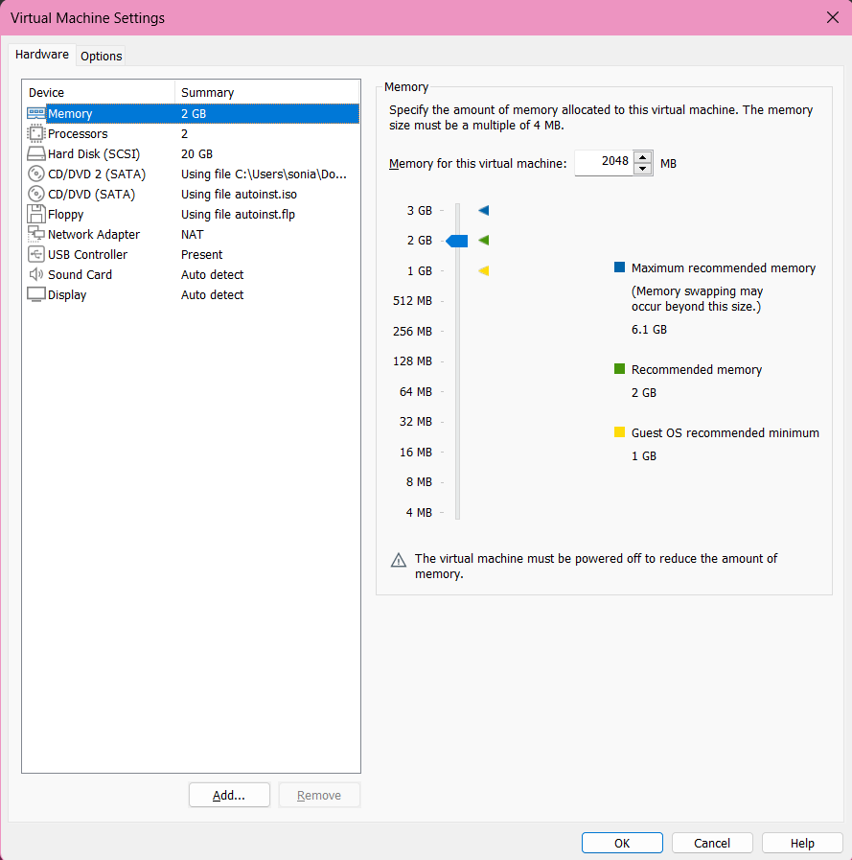
- Selecting/adding equipment available for the virtual machine:
Click “VM” in the top panel, “Settings”, in the hardware tab you can add new devices such as network adapters, additional disks, USB devices.

- Setting up the network and connecting to Wi-Fi points:
Add or configure a network adapter for the virtual machine in the same hardware tab, choose the type of network: standard network or Wi-Fi network.
- Ability to work with external storage (flash memory):
In the hardware tab you can add a new USB controller or USB device by this option. Connecting the external storage is made by selecting it from the list of USB devices.
Made by Ihor Kohut:
3. Install the GNU/Linux CentOS operating system (or other convenient distribution for you) in your hypervisor in a basic configuration with a graphical program.
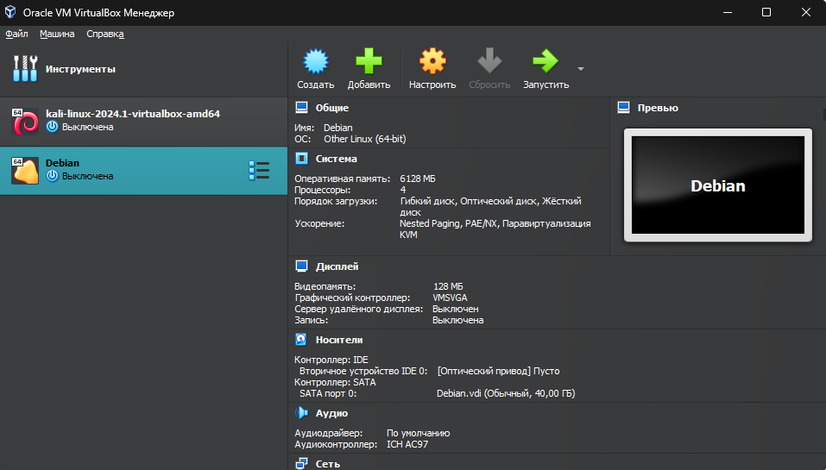
To create an operating system in the hypervisor, you need to click the “Create” button, then set the name of the new system, select the system you need from the list of systems and load the system ISO file. It’s also worth setting up memory, RAM and how many processor cores the system will use, I configured all this in the window before the first launch (installation) of the system.
Then press run.
Selecting the Graphical install
Selecting English language
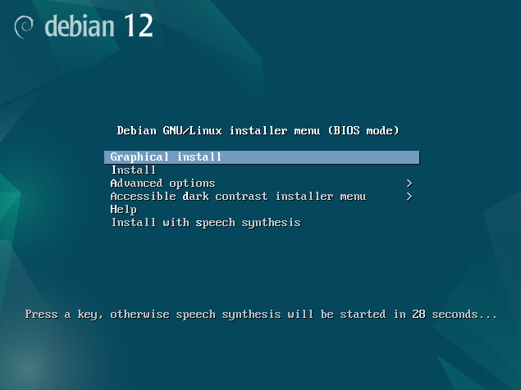
Next step: select country – Ukraine, and select the keyboard layout
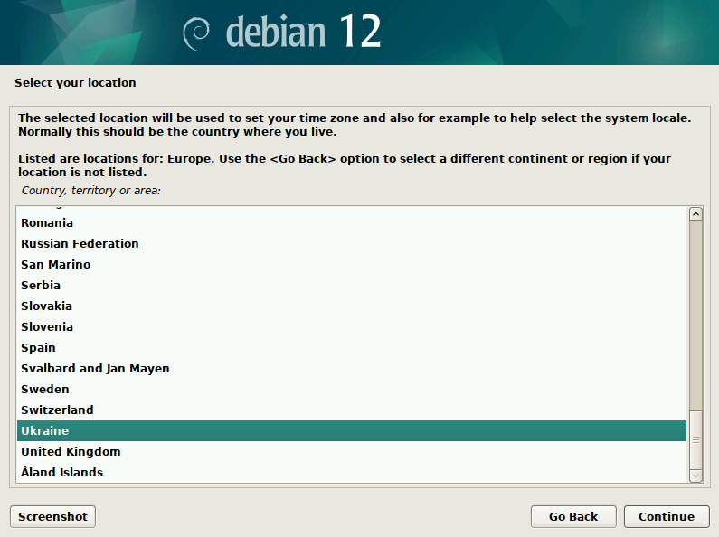
Installation begins. Then we set the root and user passwords. Next is a window with disk selection, select the first item and select our disk.
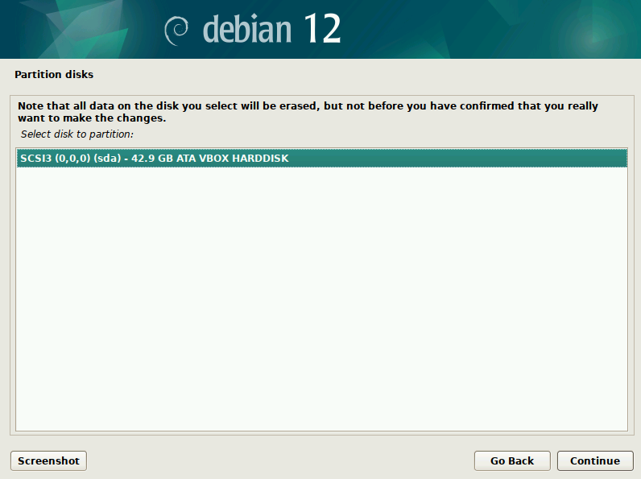
Press “Yes”.
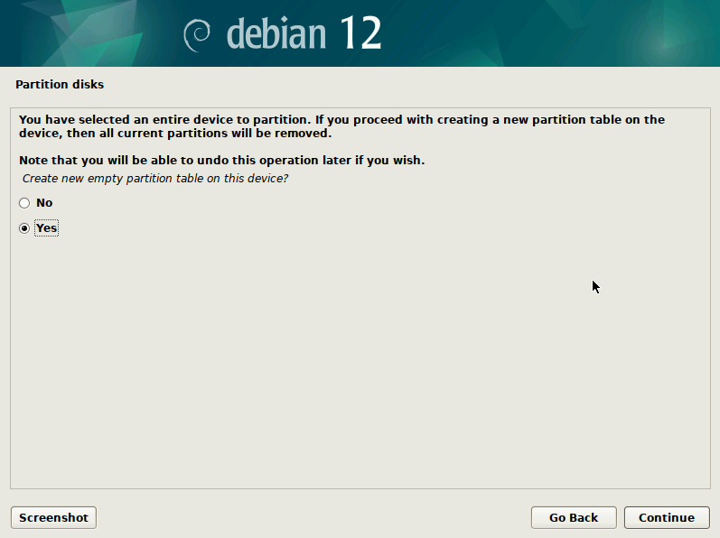
Installing…
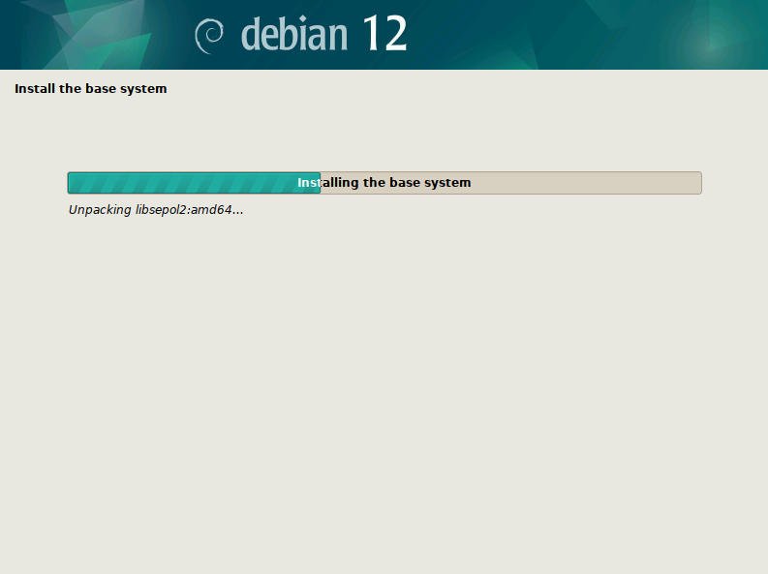
Set the region to Ukraine so that it is correctly connected to the mirror and set deb.debian.org
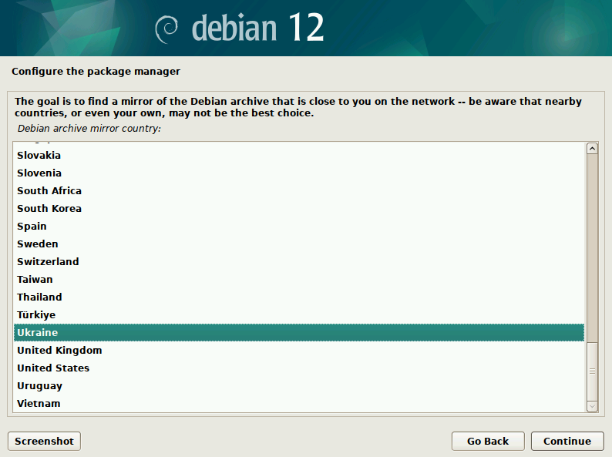
Select desktop environment – GNOME
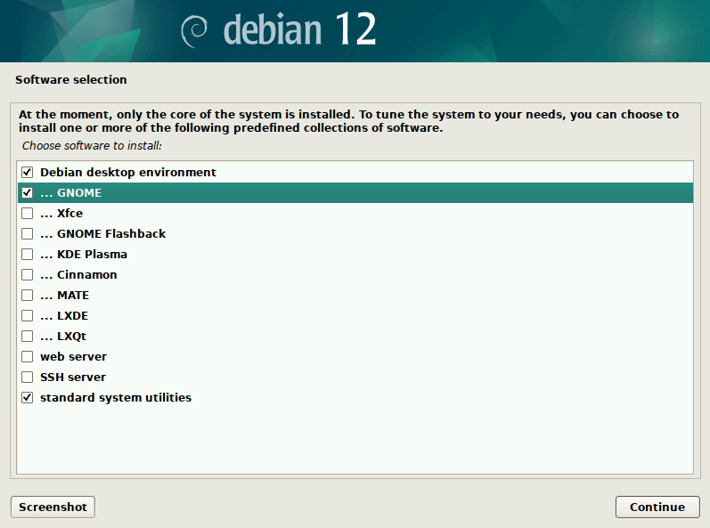
Installing…
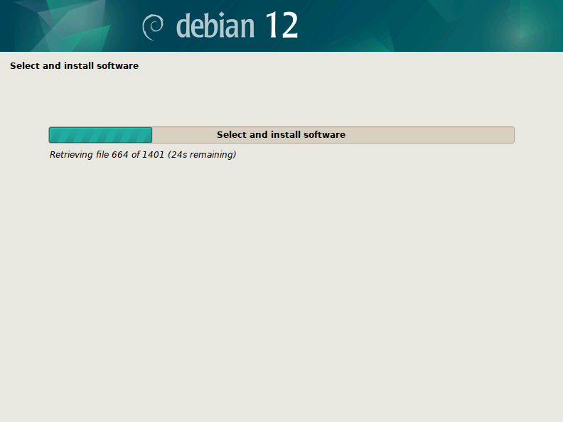
Installation is complete. Click continue.
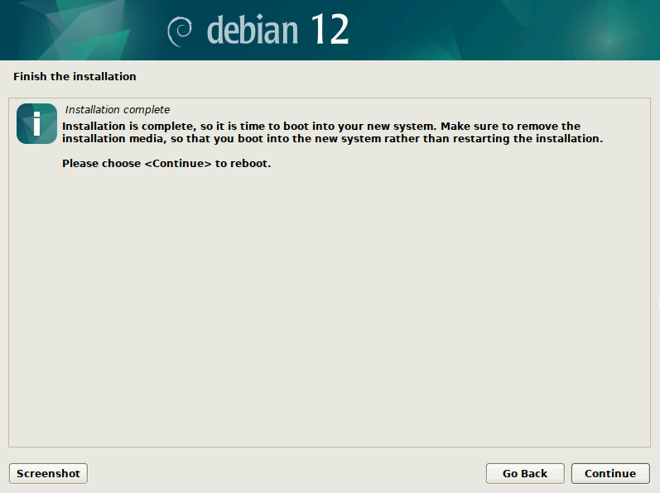
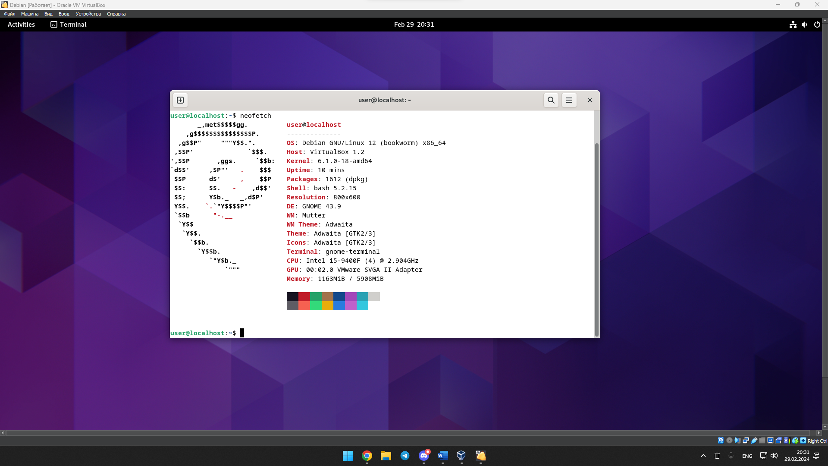

4. Bereza
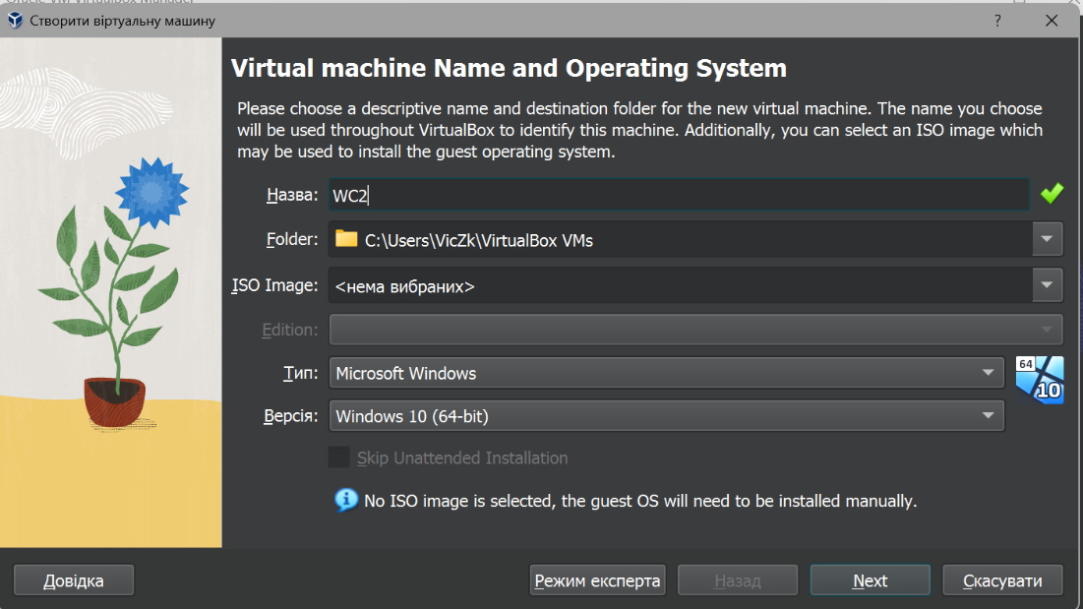Create new machine

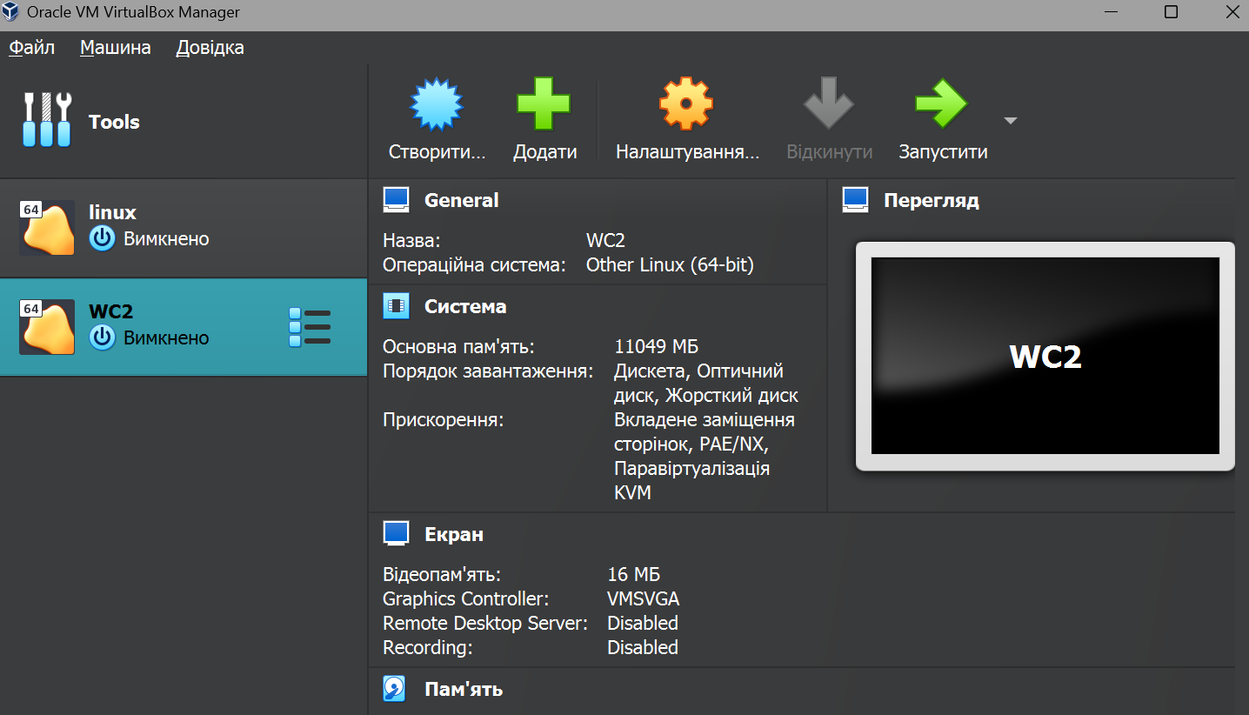 start
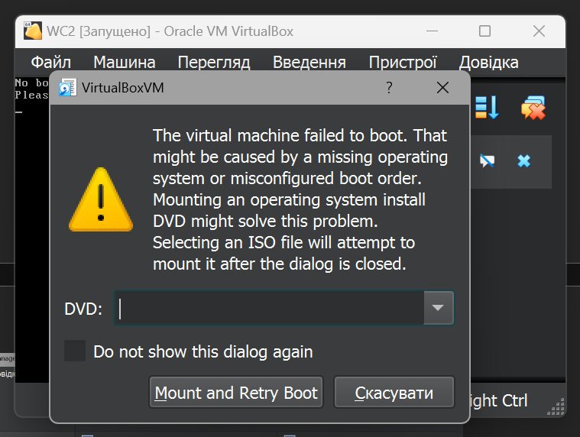 choose debianGNU.iso

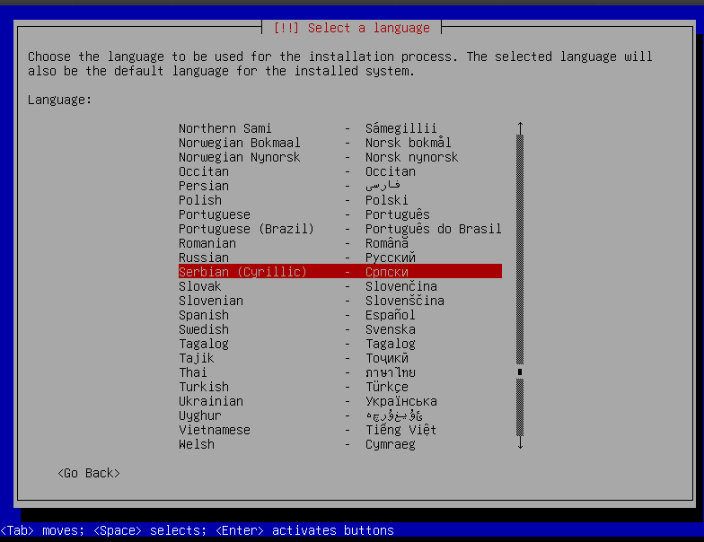Without grafical install
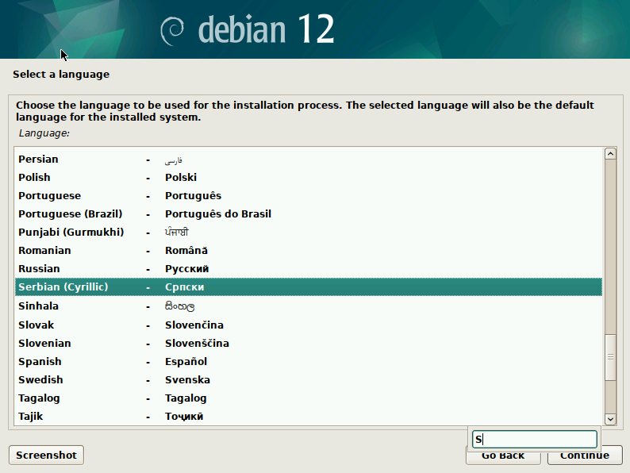With grafical
Install GNOME
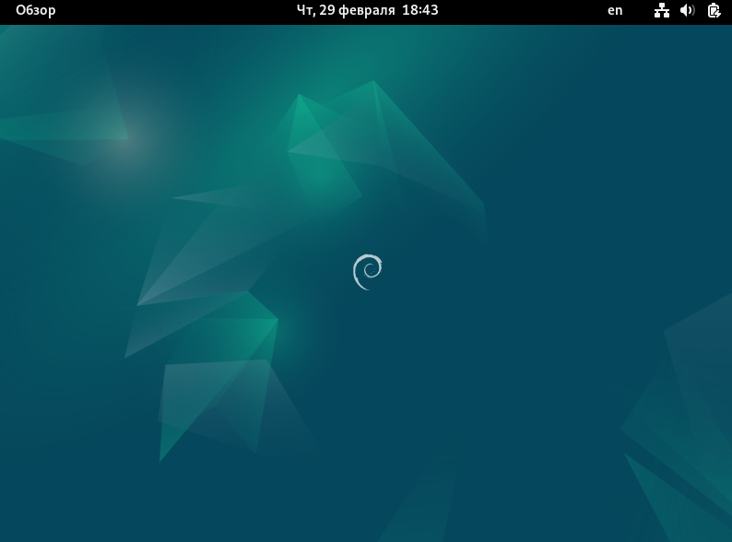After install GNU with CNOME

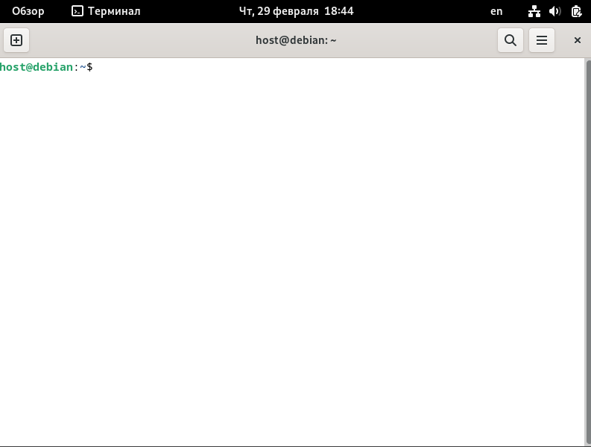Terminal

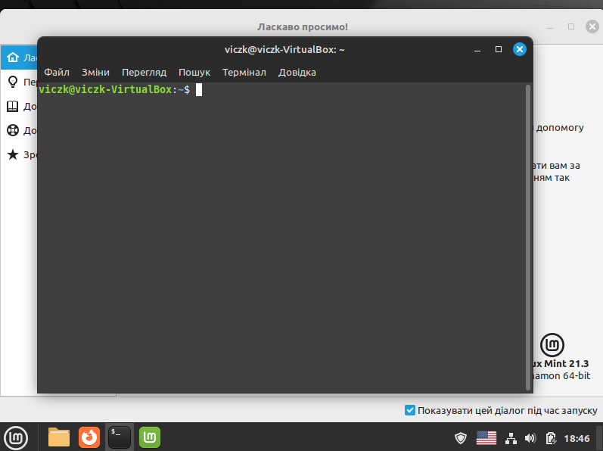It`s how look mint

